Implementing a Zero Trust Architecture through Adaptive Security Policies.

LIST OF TEAMMATES:
S.no | NAME | COLLEGE NAME | CONTACT
1. | Anandhi V | SRI KRISHNA ADITHYA COLLEGE OF ARTS AND SCIENCE | 23bscs104anandhiv@skacas.ac.in
2. | Jaishi R | SRI KRISHNA ADITHYA COLLEGE OF ARTS AND SCIENCE | 23bscs119jaishirajkumar@skacas.ac.in
3. | Nithul sasikumar | SRI KRISHNA ADITHYA COLLEGE OF ARTS AND SCIENCE | 23bscs138nithulsasikumar@skacas.ac.in
4. | Dharshini J | SRI KRISHNA ADITHYA COLLEGE OF ARTS AND SCIENCE | 23bscs116dharshinij@skacas.ac.in
5. | Janani G | SRI KRISHNA ADITHYA COLLEGE OF ARTS AND SCIENCE | 23bscs120jananig@skacas.ac.in

PROJECT TITLE
Implementing a Zero Trust Architecture through Adaptive Security Policies

INTRODUCTION:

In today’s hyper‑connected digital ecosystem, user to app traffic has become the lifeline of modern services, yet it is increasingly exposed to sophisticated cyber threats such as interception, injection, and data exfiltration. Traditional security measures static firewalls and signature-based detection are no longer sufficient to protect the dynamic flow of data between users and applications, especially as environments shift toward cloud‑native architectures, mobile devices, and remote access. The evolving attack surface demands intelligent, real‑time defences that can analyse traffic behaviour, identify anomalies, and enforce adaptive security policies.

This project investigates the *Role of AI in Securing User‑to‑App Traffic*, focusing on the design and implementation of an AI‑driven security framework that monitors, analyses, and safeguards every interaction between users and applications. By leveraging machine‑learning models for anomaly detection, behavioural analytics, and predictive risk assessment, the system moves beyond conventional perimeter defences to provide granular, context‑aware protection of data in transit. The framework ingests multiple signals user identity, device posture, geolocation, application sensitivity, and traffic patterns to compute a real‑time risk score for each session, enabling automated responses such as traffic encryption, session termination, or multi‑factor authentication challenges.

The ultimate goal is to build a resilient security architecture that reduces exposure to traffic‑based attacks, ensures data integrity and confidentiality, and delivers a frictionless experience for legitimate users while dynamically throttling or blocking malicious or high‑risk interactions. By embedding AI into the traffic‑security pipeline, organizations to the ever-changing threat landscape and protect user‑to‑app communications in a perimeter less world.

ABSTRACT:

The proliferation of mobile and cloud‑based applications has expanded the attack surface for user‑to‑app traffic, making legacy security methods inadequate against modern threats like man‑in‑the‑middle attacks, data leakage, and session hijacking. There is a pressing need for intelligent, adaptive mechanisms that can secure data flows in real time while respecting user experience.

This project presents an AI‑centric approach to securing user‑to‑app traffic, centred on a context‑aware security engine that fuses user identity, device health, location, application risk, and traffic behaviour to generate a dynamic risk score for each session. The engine employs machine‑learning algorithms for anomaly detection, predictive threat modelling, and automated policy enforcement, mapping risk scores to actions such as transparent encryption, session isolation, step‑up authentication, or traffic blocking.

The expected outcome is an agile security model that dramatically shrinks the attack surface of user‑to‑app communications, mitigates data breaches, and maintains seamless functionality for trusted interactions. By aligning security decisions with the real‑time context of each traffic event, the AI‑driven system provides robust protection without introducing unnecessary friction, enabling secure and efficient user‑application experiences in a distributed digital environment.

USE CASE SCENARIOS:

Scenario 1: Finance Department Access to ERP System

- In this scenario, a senior accountant needs to access the organization’s Enterprise Resource Planning (ERP) system to process monthly payroll from a remote location. The employee connects using a company-managed laptop and launches the ZPA Client Connector.
- The system authenticates the user through Azure Active Directory with Multi-Factor Authentication (MFA). Adaptive security policies then evaluate several factors, including the user’s identity, membership in the Finance_ERP_Users group, device security status, and the connection context.

Output:

- User authenticated and authorized through adaptive policy evaluation
- Direct micro-tunnel created specifically for the ERP application
- Other internal systems remain invisible and inaccessible

Scenario 2: Contractor Access to Specific Project Repository

- An external software contractor is hired for a three-month project and requires access only to a specific internal Git repository. The contractor is onboarded as a guest user in the identity provider and assigned to the Project_X_Contractors group.

- When the contractor connects using the ZPA client, adaptive security policies verify the user’s identity and evaluate device compliance, including operating system patch level and firewall status. The policy allows access exclusively to the Git repository through approved ports (SSH port 22 or HTTPS port 443) and restricts access to business hours from 9 AM to 5 PM.

Output:

- Time-bound and role-specific access enforced
- Contractor restricted to a single application (Git repository)
- Lateral movement to other internal systems completely blocked

Scenario 3: Executive Access to Sensitive Financial Documents

- A company vice president needs to access confidential merger and acquisition documents stored in a corporate SharePoint repository. The executive connects from an international hotel business centre using a company-managed tablet.
- After launching the ZPA Client Connector, the user authenticates through Azure Active Directory with MFA. Adaptive security policies analyse identity, executive group membership, device posture, and connection location. While the device is compliant, the login originates from an unusual foreign location, increasing the risk score.
- This scenario demonstrates how adaptive security policies dynamically adjust access privileges based on risk level.

Output:

- User authenticated but flagged due to unusual geographic location
- Read-only access granted with download and print restrictions
- Security team alerted for potential risk monitoring

Scenario 4: Remote Support Technician Access to Internal Tools

- An IT support technician needs to access internal support tools to assist an employee experiencing technical issues. The technician connects from a home office using a company-managed desktop computer.
- This scenario demonstrates how adaptive policies provide secure but limited access for operational tasks.

Output:

- User authenticated and authorized based on trusted context
- Micro-tunnels created for support applications only
- Least-privilege access maintained across the network

Scenario 5: High-Risk Application Access from a Low-Trust Location

- A marketing coordinator needs to update a campaign in the company’s customer relationship management system while working from a coffee shop using public Wi-Fi. The employee connects through the ZPA Client Connector on a company-managed smartphone and authenticates using Azure Active Directory with MFA.
- Instead of blocking access, the Zero Trust system routes the session through a secure browser isolation service. The CRM interface is rendered in a disposable remote container, preventing sensitive data from being stored on the device or exposed through the public network. Additional controls such as copy-paste and download restrictions are also enforced.
- This scenario highlights how adaptive policies can safely enable productivity even in high-risk environments.

Output:

- User authenticated and device compliant but network marked high risk
- Access granted through secure browser isolation
- Data download and copy-paste controls enforced to prevent leakage

STAGE-1
Overview:
Title:
Implementing a Zero Trust Architecture through Adaptive Security Policies to systems has become a major challenge. Traditional access control mechanisms mainly rely on static authentication methods such as usernames, passwords, or even two-factor authentication. While these methods provide a basic level of protection, they are often vulnerable to modern in today’s digital world, protecting sensitive information and preventing unauthorized access cyber threats such as phishing attacks, credential theft, brute-force attacks, and unauthorized login attempts. As a result, relying solely on fixed credentials is no longer sufficient to ensure secure access to digital systems.
Implementing a Zero Trust Architecture through Adaptive Security Policies to systems has become a major challenge project aims to improve system security by introducing an intelligent access control mechanism that evaluates not only the user’s identity but also the context in which the access request is made. Context-aware access control considers additional factors such as the user’s location, device type, login time, and network environment before granting or denying access to a system. By combining identity verification with contextual information, the system can make more accurate and secure access decisions.
In this system, when a user attempts to log in, the system first verifies the user’s identity using registered credentials. After successful authentication, the system analyses contextual parameters such as whether the login is coming from a trusted device, whether the location is recognized, and whether the login time falls within expected usage patterns. If the context matches the trusted conditions, the system grants access to the requested resources. However, if unusual behaviour is detected, such as login attempts from unknown devices or suspicious locations, the system may request additional verification or temporarily restrict access.
This approach helps organizations strengthen their security by ensuring that access decisions are not based solely on passwords or static authentication methods. Instead, the system continuously evaluates contextual factors to detect potential security risks and prevent unauthorized access. For example, if an attacker gains access to a user's credentials and attempts to log in from an unfamiliar location or device, the context-aware system can identify this abnormal behaviour and block the request before any damage occurs.
Another key advantage of context-aware access control is its ability to provide a balance between security and usability. Legitimate users who access the system from trusted environments can log in smoothly without unnecessary interruptions, while suspicious activities are carefully monitored and controlled. This intelligent approach reduces the chances of security breaches while maintaining a user-friendly experience.
The implementation of this project demonstrates how modern access control systems can be improved by integrating contextual awareness with user identity verification. By analyzing multiple factors during the authentication and authorization process, the system can provide a stronger layer of protection against cyber threats. This makes the proposed solution suitable for applications in organizations, cloud services, enterprise systems, and other digital platforms that require secure and reliable access control mechanisms.
Overall, Implementing a Zero Trust Architecture through Adaptive Security Policies to systems has become a major challenge project provides a modern security solution that enhances traditional authentication methods by incorporating contextual analysis. This system helps protect sensitive information, prevent unauthorized access, and improve the overall security posture of digital environments. As cyber threats continue to evolve, implementing intelligent access control mechanisms like this will play a crucial role in safeguarding digital systems and ensuring secure user interactions.

 | Vulnerability Name | CWE-NO
1. | Improper Access Control | CWE-284
2. | Improper Authorization | CWE-285
3. | Exposure of Private Personal Information to an Unauthorized Actor | CWE-359
4. | Process Control | CWE-114
5. | Password in Configuration File | CWE-260
6. | Dependency on Vulnerable Third-Party Component | CWE-1395
7. | Improper Verification of Cryptographic Signature | CWE-347
8. | Improper Certificate Validation | CWE-295
9. | Untrusted Search Path | CWE-426
10. | Insufficient Logging | CWE-778

REPORT:
1) Vulnerability Name:
Improper Access Control
- CWE/CVE:
CWE-284

- OWASP/SANS Category:
A01:2025 Broken Access Control

- Description:
Improper Access Control occurs when a system does not correctly restrict user permissions. This allows users to access data or perform actions that they are not authorized to perform due to missing or weak authorization checks.

- Business Impact:
This vulnerability can lead to unauthorized access to sensitive information, data modification, or misuse of system resources. It may result in data breaches, financial loss, and damage to an organization’s reputation.

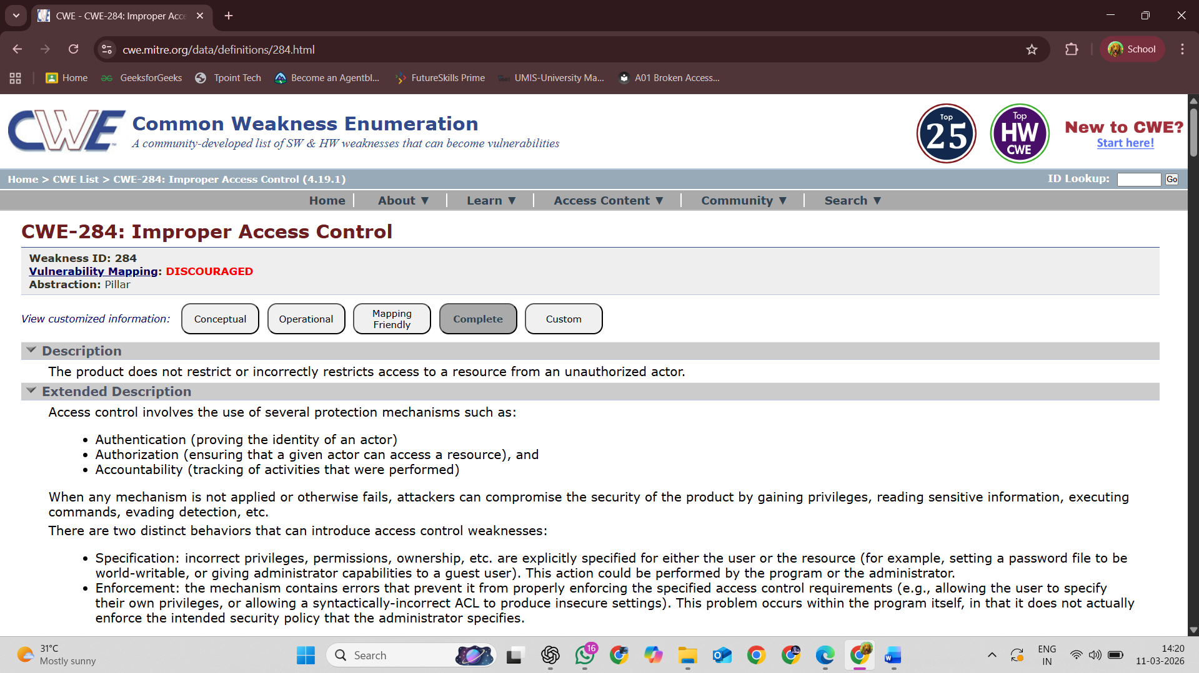

2) Vulnerability Name:
Improper Authorization
- CWE/CVE:
CWE-285
- OWASP/SANS Category:
A01:2025 Broken Access Control
- Description:
Improper Authorization occurs when a system fails to correctly verify whether a user has permission to perform a specific action or access certain resources. As a result, users may be able to perform operations beyond their assigned privileges.
- Business Impact:
This vulnerability can allow unauthorized users to access restricted data or perform sensitive operations. It may lead to data breaches, unauthorized system changes, and potential financial and reputational damage to the organization.
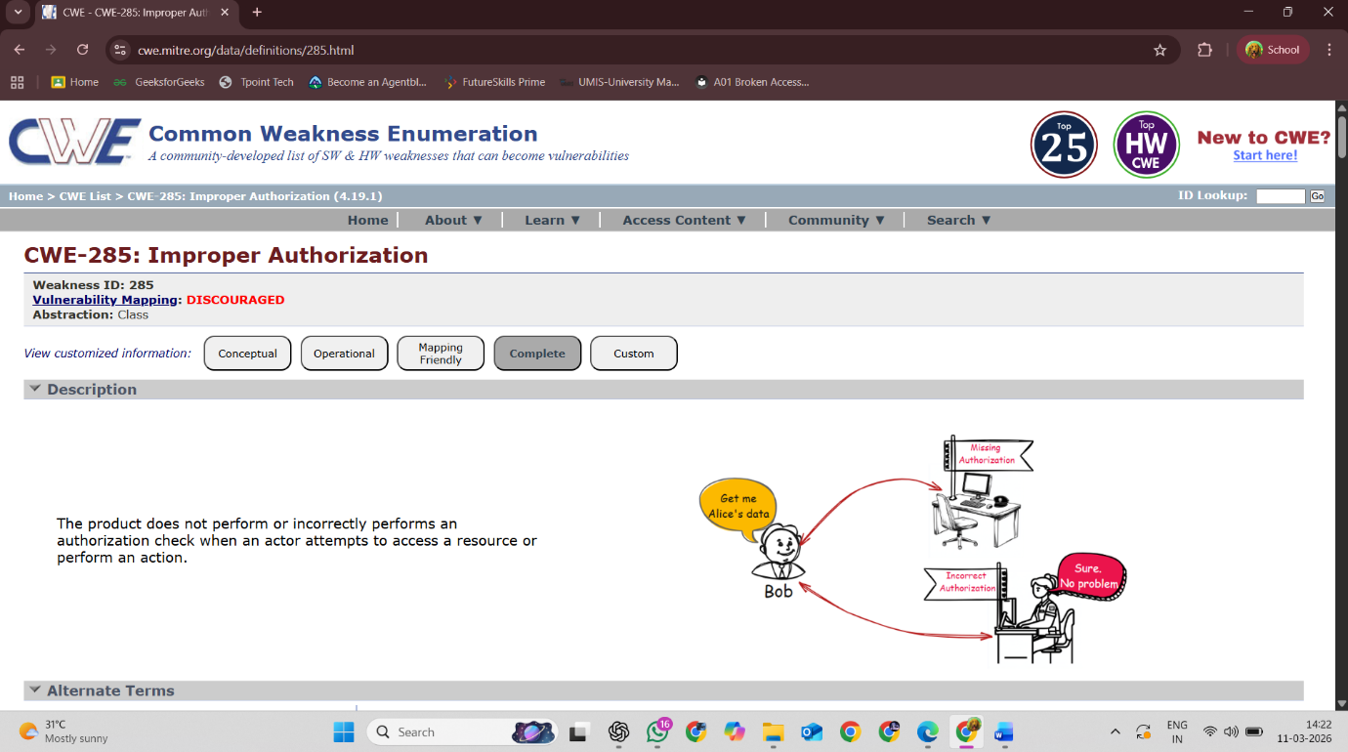

3) Vulnerability Name:
Exposure of Private Personal Information to an Unauthorized Actor
- CWE/CVE:
CWE-359
- OWASP/SANS Category:
A01:2025 Broken Access Control
- Description:
This vulnerability occurs when a system unintentionally exposes sensitive personal information such as names, addresses, phone numbers, or financial details to unauthorized users. It usually happens due to weak security controls or improper data protection mechanisms.
- Business Impact:
Exposure of personal information can lead to privacy violations, identity theft, and legal consequences for organizations. It can also damage customer trust and harm the organization’s reputation.

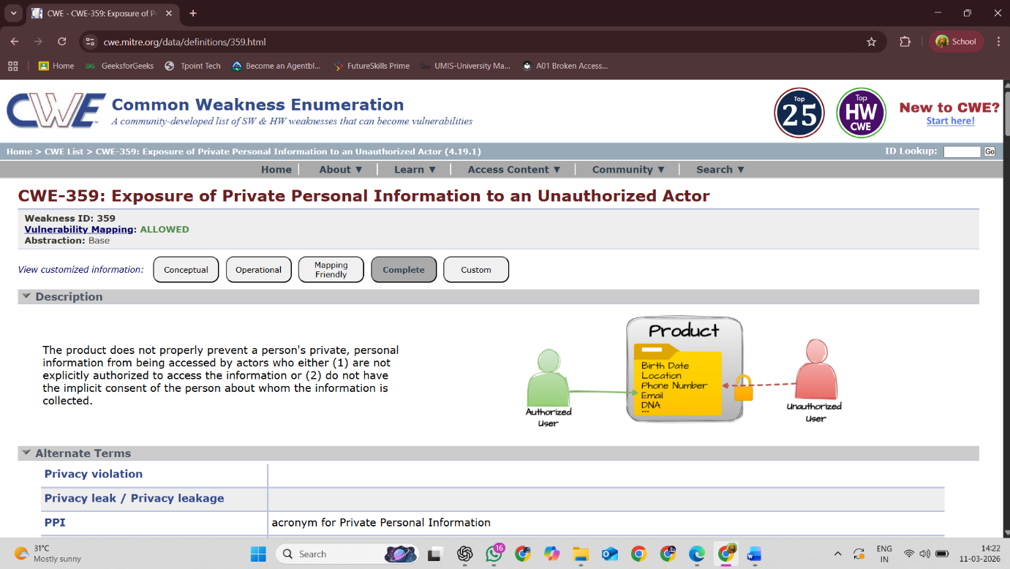

4) Vulnerability Name:
Process Control
- CWE/CVE:
CWE-114
- OWASP/SANS Category:
A05:2025 Injection
- Description:
This vulnerability occurs when a system improperly controls how external programs or processes are loaded or executed. Attackers may exploit this weakness to run malicious code within the application.
- Business Impact:
Exploitation of this vulnerability can allow attackers to execute unauthorized programs, potentially leading to system compromise, data breaches, or disruption of business operations.

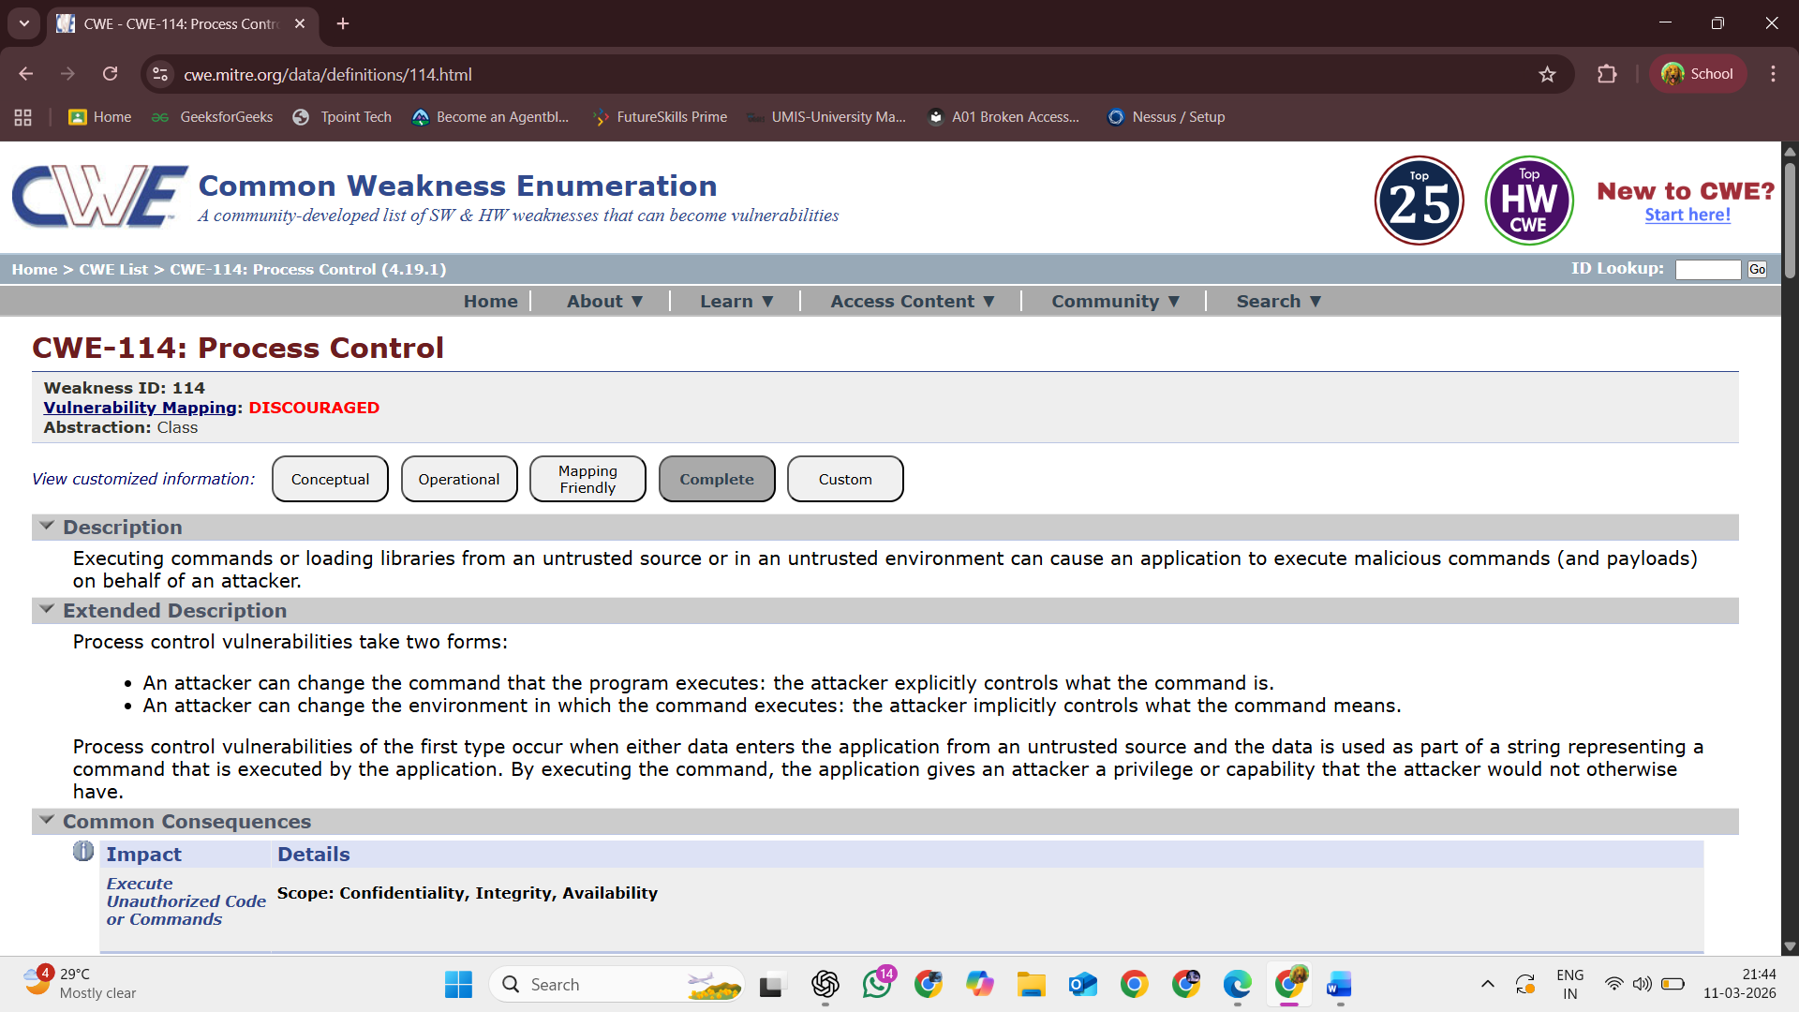

5) Vulnerability Name:
Password in Configuration File
- CWE/CVE:
CWE-260
- OWASP/SANS Category:
A02:2025 Security Misconfiguration
- Description:
This vulnerability occurs when passwords are stored directly in configuration files without proper protection. If attackers gain access to these files, they can easily retrieve the credentials and misuse them.
- Business Impact:
Exposed passwords may allow attackers to gain unauthorized access to systems, databases, or applications. This can result in data breaches, system compromise, and significant security risks for the organization.

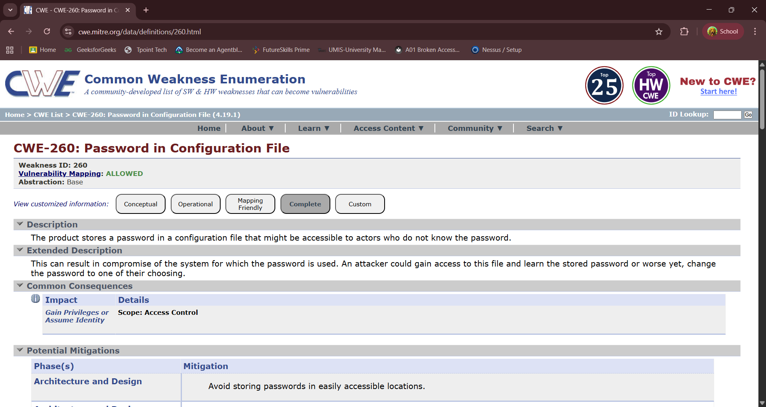

6) Vulnerability Name:
Dependency on Vulnerable Third-Party Component
- CWE/CVE:
CWE-1395
- OWASP/SANS Category:
A03:2025 Software Supply Chain Failures
- Description:
This vulnerability occurs when an application relies on third-party libraries or components that contain known security flaws. If these components are not updated or properly managed, attackers may exploit their vulnerabilities to compromise the system.
- Business Impact:
Using vulnerable third-party components can expose the system to security attacks, data breaches, or unauthorized access. It may also lead to system instability, operational risks, and damage to the organization’s reputation.

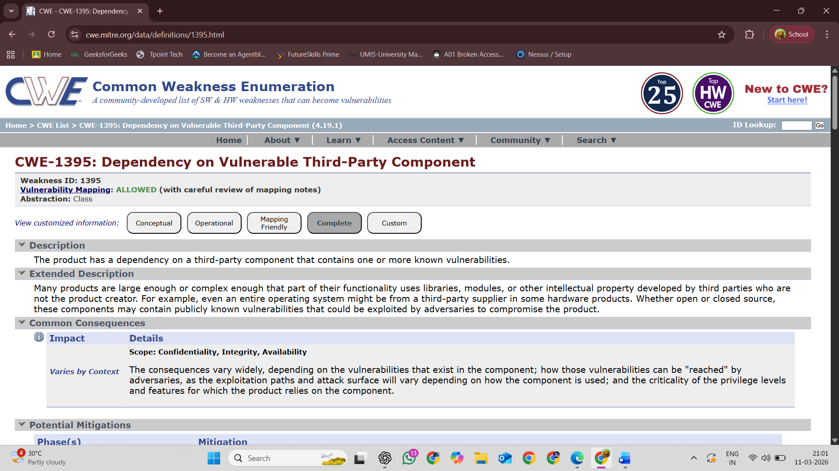

7) Vulnerability Name:
Improper Verification of Cryptographic Signature
- CWE/CVE:
CWE-347
- OWASP/SANS Category:
A04:2025 Cryptographic Failures
- Description:
This vulnerability occurs when a system does not properly verify cryptographic signatures used to validate the authenticity and integrity of data or software. As a result, modified or malicious data may be accepted as valid.
- Business Impact:
Attackers may exploit this weakness to bypass security checks, distribute malicious content, or tamper with sensitive data, leading to system compromise and security breaches.

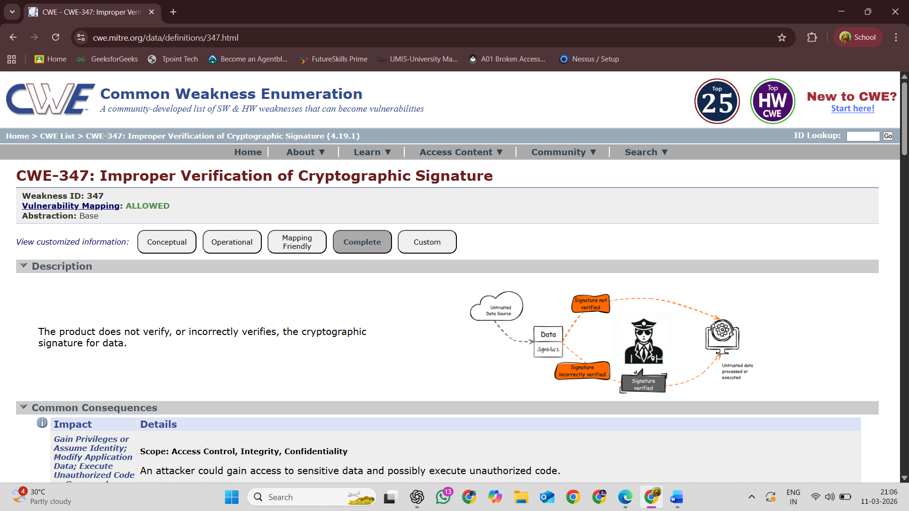

8) Vulnerability Name:
Improper Certificate Validation
- CWE/CVE:
CWE-295
- OWASP/SANS Category:
A07:2025 Authentication Failures
- Description:
This vulnerability occurs when a system does not properly validate digital certificates during secure communication. As a result, attackers may present fake or invalid certificates and intercept or manipulate the communication.
- Business Impact:
Improper certificate validation can allow attackers to perform man-in-the-middle attacks, steal sensitive information, or compromise secure communications, leading to serious security risks for the organization.
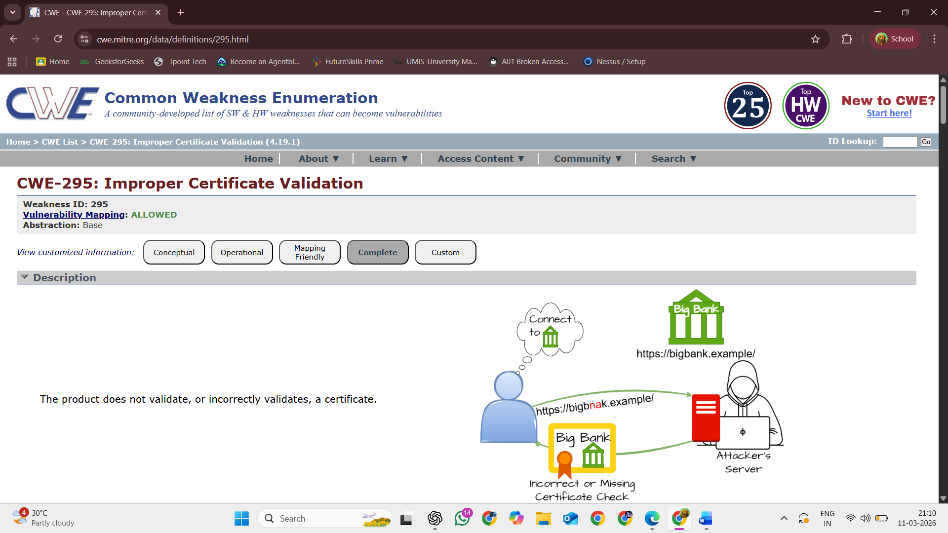

9) Vulnerability Name:
Untrusted Search Path
- CWE/CVE:
CWE-426
- OWASP/SANS Category:
A08:2025 Software or Data Integrity Failures
- Description:
This vulnerability occurs when a system searches for executable files in untrusted directories before trusted ones. Attackers can place malicious files in these locations, causing the system to execute the attacker’s code instead of the intended program.
- Business Impact:
Exploitation of this vulnerability can allow attackers to execute malicious code, gain unauthorized system access, or compromise system integrity, leading to serious security and operational risks.

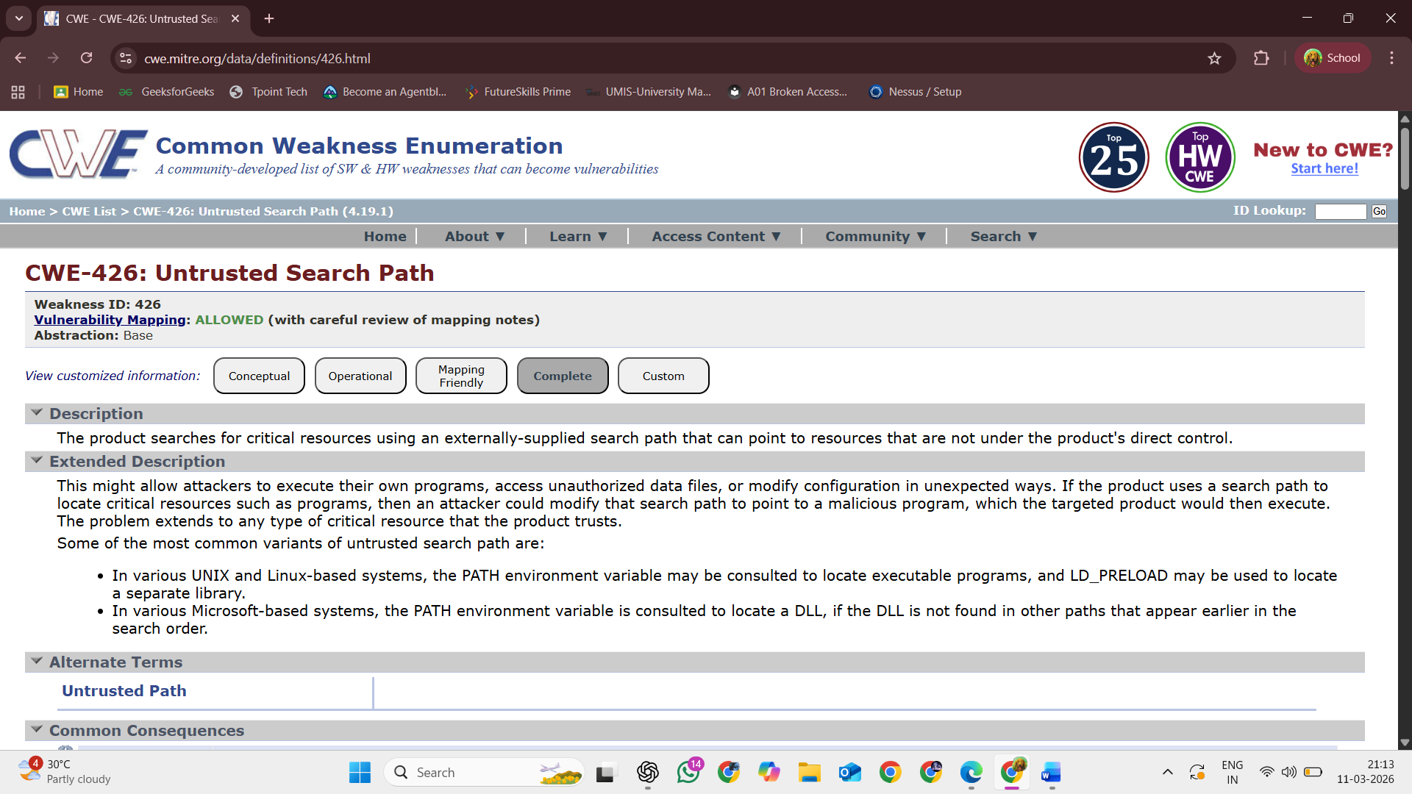

10) Vulnerability Name:
Insufficient Logging
- CWE/CVE:
CWE-778
- OWASP/SANS Category:
A09:2025 Security Logging and Monitoring Failures
- Description:
This vulnerability occurs when a system does not properly record important security events or user activities. As a result, suspicious actions or attacks may go unnoticed.
- Business Impact:
Without proper logging, organizations may be unable to detect, investigate, or respond to security incidents effectively. This can lead to prolonged attacks, data breaches, and difficulty in identifying the source of security issues.

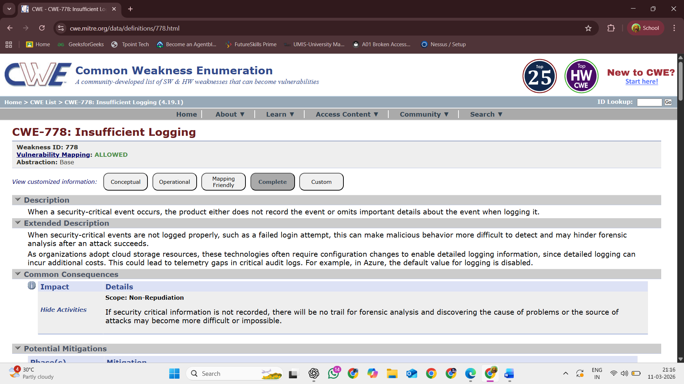

STAGE 2
Overview:
Nessus is one of the most widely used vulnerability scanning tools designed to identify security weaknesses in computer systems, networks, and web applications. It was developed by Tenable and is commonly used by security professionals, system administrators, and organizations to detect potential vulnerabilities before attackers can exploit them. Nessus helps improve system security by scanning devices such as servers, databases, websites, and network infrastructure to find misconfigurations, outdated software, and other security risks.
Nessus works by comparing the scanned system against a large database of known vulnerabilities and security issues. It uses regularly updated vulnerability plugins to detect problems such as missing patches, weak security settings, exposed services, and outdated components. Once the scan is completed, Nessus generates a detailed report that lists the vulnerabilities found, their severity levels, and recommendations for fixing them. This helps organizations understand their security posture and take corrective actions to strengthen their systems.
Nessus is widely used in vulnerability assessment and penetration testing processes. It supports multiple scanning methods including network scanning, web application scanning, and configuration auditing. Because of its accuracy, user-friendly interface, and comprehensive vulnerability database, Nessus has
become an essential tool for maintaining cybersecurity in modern IT environments.
Here is a step-by-step explanation of how Nessus works:
- Installation and Setup
First, the Nessus software is installed on a system and activated with a license key. After installation, the user accesses the Nessus web interface through a browser.

- Plugin Update
Nessus downloads and updates its vulnerability plugins. These plugins contain information about the latest vulnerabilities, security checks, and configuration issues.
- Creating a Scan
The user creates a new scan by specifying the target system such as an IP address, domain name, or network range that needs to be tested.
- Scan Configuration
The scanning options are configured, including scan type, credentials (if required), and vulnerability checks.
- Vulnerability Scanning
Nessus begins scanning the target system. It checks open ports, services, operating systems, and installed software to identify potential vulnerabilities.
- Vulnerability Detection
The scanner compares the results with its vulnerability database to detect known security weaknesses and misconfigurations.
- Report Generation
After the scan is completed, Nessus generates a detailed report showing the vulnerabilities discovered, their severity levels (Low, Medium, High, Critical), and recommendations for fixing them.
Target website: https://ginandjuice.shop/
Target IP Address: 34.246.169.176

tup
- Plugin Update
Nessus downloads and updates its vulnerability plugins. These plugins contain information about the latest vulnerabilities, security checks, and configuration issues.
- Creating a Scan
The user creates a new scan by specifying the target system such as an IP address, domain name, or network range that needs to be tested.
- Scan Configuration
The scanning options are configured, including scan type, credentials (if required), and vulnerability checks.
- Vulnerability Scanning
Nessus begins scanning the target system. It checks open ports, services, operating systems, and installed software to identify potential vulnerabilities.
- Vulnerability Detection
The scanner compares the results with its vulnerability database to detect known security weaknesses and misconfigurations.
- Report Generation
After the scan is completed, Nessus generates a detailed report showing the vulnerabilities discovered, their severity levels (Low, Medium, High, Critical), and recommendations for fixing them.
Target website: https://ginandjuice.shop/
Target IP Address: 34.246.169.176

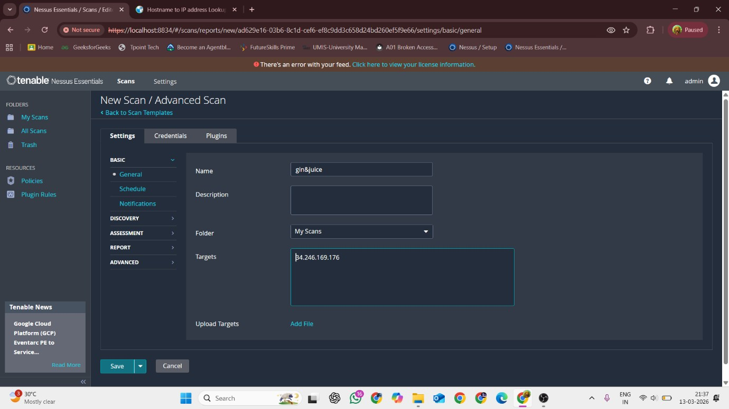

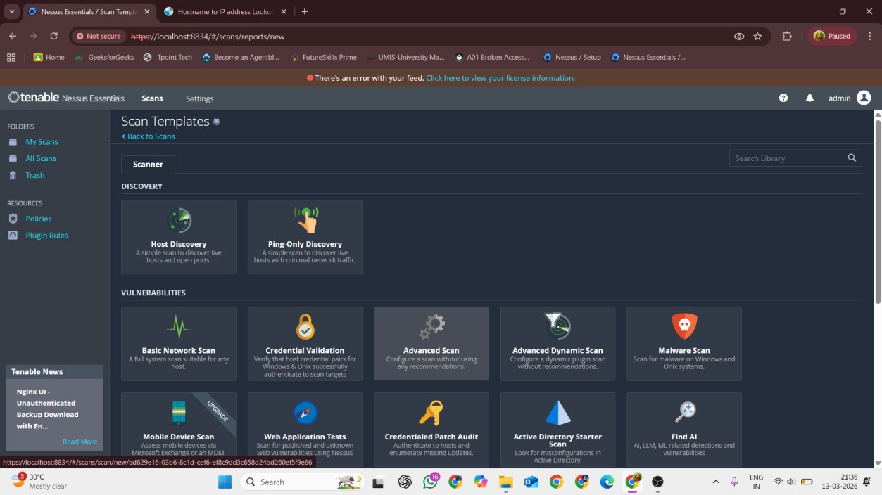
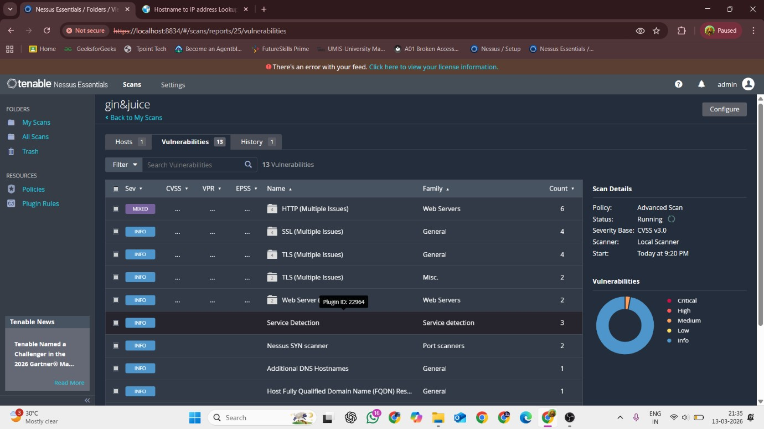

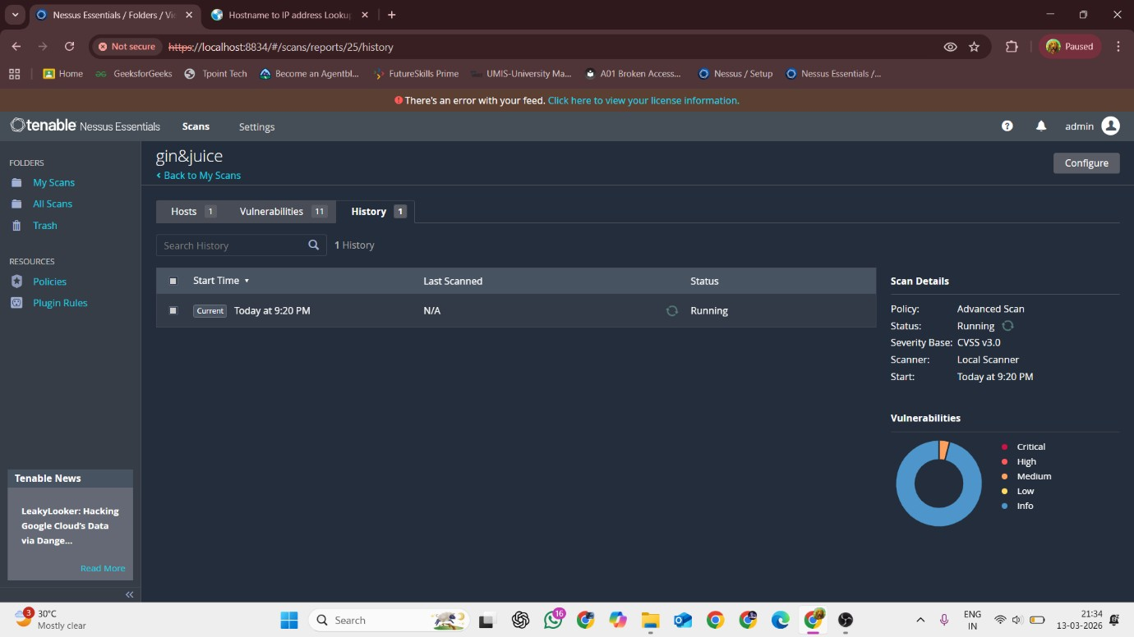

LIST OF VULNERABILITIES:

S.NO | Vulnerability name | Severity | Plugins
1. | Service detection | INFO | 22964
2 | Nessus SYN scanner | INFO | 11219
3. | Additional DNS Hostnames | INFO | 46180
4. | Host Fully Qualified Domain Name (FQDN) Resolution | INFO | 12053
5. | Nessus Scan Information | INFO | 19506
6. | OS Fingerprints Detected | INFO | 205694
7. | Remote Services Not Using Post-Quantum Ciphers | INFO | 277650
8. | Shor's Harvest Now Decrypt  Later | INFO | 298387
9. | SSL Root Certification  Authority Certificate  Information | INFO | 94761
10. | Traceroute Information | INFO | 10287

REPORT:
1)Vulnerability Name: Service Detection
Plugin ID:
22964

Severity:
Info
Port: 443/tcp/www
Description:
This plugin identifies the network services running on open ports of the target system. It detects the service type and version information to help determine potential vulnerabilities associated with those services.

Severity:
Info
Port: 443/tcp/www
Description:
This plugin identifies the network services running on open ports of the target system. It detects the service type and version information to help determine potential vulnerabilities associated with those services.

Solution:
No specific fix is required because this is an informational plugin. However, administrators should review detected services and disable any unnecessary or unused services to reduce the attack surface.
Business Impact:
Service detection itself is not a vulnerability, but exposing unnecessary services may provide attackers with useful information about the system, which could help them plan further attacks.

2)Vulnerability Name: Nessus SYN Scanner
Plugin ID:
11219
Severity:
Info
Port: 443/tcp/www
Description:
This plugin performs a SYN scan to identify open TCP ports on the target system. It sends SYN packets to determine which ports are listening for connections and which services are available.
Solution:
No direct fix is required because this is an informational check. However, administrators should review open ports and close or restrict any unnecessary services through firewall rules or system configuration.
Business Impact:
While this is not a vulnerability, open ports may expose services that attackers could target. Unnecessary open ports can increase the attack surface and potentially allow unauthorized access to the system.

Business Impact:
While this is not a vulnerability, open ports may expose services that attackers could target. Unnecessary open ports can increase the attack surface and potentially allow unauthorized access to the system.

3) Vulnerability Name: Additional DNS Hostnames
Plugin ID:
46180
4)Vulnerability Name:
Host Fully Qualified Domain Name (FQDN) Resolution
Plugin ID:
12053
Severity:
Info
Port: N/A
Description:
This plugin attempts to resolve the Fully Qualified Domain Name (FQDN) of the target host using DNS queries. It helps identify the domain name associated with the scanned IP address.
Solution:
No direct fix is required because this is an informational finding. However, organizations should ensure that DNS records are properly configured and avoid exposing unnecessary domain information.
Business Impact:
Although this is not a direct vulnerability, revealing the host’s domain name may provide attackers with useful information about the network structure, which could assist in reconnaissance and targeted attacks

5)Vulnerability Name:
Nessus Scan Information
Plugin ID:
19506
Severity:
Info
Port: N/A
Description:
This plugin provides general information about the Nessus scan, including the scan start time, scan duration, scanner version, and other details related to the scanning process. It helps users understand how and when the scan was performed.
Solution:
No action is required because this is an informational plugin. It simply records details about the scan for reporting and documentation purposes.
Business Impact:
There is no direct security impact because this is not a vulnerability. It only provides information about the scanning process and helps in maintaining proper security assessment records.

6) Vulnerability Name: OS Fingerprints Detected
Plugin ID:
205694
Severity:
Info
Port: N/A

Description:
This plugin identifies the operating system of the target system by analyzing network responses and system characteristics. It helps determine the type and version of the operating system running on the scanned host.
Solution:
No direct fix is required because this is an informational result. However, administrators should ensure that operating systems are regularly updated with the latest security patches and avoid exposing unnecessary system information.
Business Impact:
Although this is not a vulnerability, revealing operating system information may help attackers identify potential weaknesses associated with that OS version, which could assist them in planning targeted attacks.

7)Vulnerability Name:
Remote Services Not Using Post-Quantum Ciphers
Plugin ID:
277650
Severity:
Info
Port:
443 (HTTPS) / Other TLS-enabled ports
Description:
This plugin reports that the remote services are not using post-quantum cryptographic ciphers. Post-quantum cryptography is designed to protect encrypted communications against potential future threats from quantum computers. The detected service currently uses traditional cryptographic algorithms.
Solution:
Administrators should monitor developments in post-quantum cryptography and consider implementing quantum-resistant cryptographic algorithms when they become widely supported and standardized
Business Impact:
Currently, this is not an immediate security risk. However, in the future, quantum computing could potentially break traditional encryption methods, which may expose sensitive communications if stronger cryptographic protections are not implemented.

8)Vulnerability Name:
Shor's Harvest Now Decrypt Later
Plugin ID:
298387
Severity:
Info
Port: N/A
Description:
This plugin indicates that the target system is using traditional cryptographic algorithms that may be vulnerable to future quantum computing attacks. Attackers could capture encrypted data now and decrypt it later when quantum computing becomes capable of breaking current encryption methods.
Solution:
Organizations should monitor developments in post-quantum cryptography and plan to implement quantum-resistant encryption algorithms once they become widely available and standardized.
Business Impact:
Although there is no immediate risk, sensitive data transmitted today could potentially be exposed in the future if attackers store encrypted traffic and later decrypt it using advanced quantum computing technologies. This could impact long-term data confidentiality.

9) Vulnerability Name:
SSL Root Certification Authority Certificate Information
Plugin ID:
94761
Severity:
Info
Port:
443
Description:
This plugin provides information about the root certification authority (CA) used in the SSL/TLS certificate of the scanned system. It identifies the trusted authority that issued or signed the certificate used for secure communication.

Solution:
No direct fix is required because this is an informational finding. However, administrators should ensure that SSL/TLS certificates are issued by trusted certification authorities and are properly configured.
Business Impact:
This is not a direct vulnerability, but certificate information may reveal details about the encryption setup of the system. Proper certificate management is important to maintain secure communications and trust between systems.

10) Vulnerability Name:
Traceroute Information
Plugin ID:
10287
Severity:
Info
Port:
0/UDP
Description:
This plugin performs a traceroute to determine the network path between the scanner and the target host. It identifies the intermediate routers and network devices through which the packets travel to reach the destination.
Solution:
No direct fix is required because this is an informational finding. However, organizations may restrict ICMP responses or traceroute-related traffic through firewall configurations to limit exposure of network infrastructure details.
Business Impact:
Although this is not a direct vulnerability, traceroute information may reveal network topology details. Attackers could use this information for reconnaissance to better understand the network structure and identify potential targets.

STAGE – 3

TITLE:
Design and apply context-aware access controls based on user identity, device posture, location, and application risk.

Context-aware access controls represent the operational pinnacle of a Zero Trust architecture, moving beyond static rules to create a dynamic and adaptive security perimeter around every application. In a modern enterprise, where users are mobile, devices are diverse, and threats are sophisticated, granting access based solely on a username and password is a dangerous oversimplification. Designing and applying context-aware controls means building a policy engine that consumes multiple, real-time signals about an access request and renders an intelligent decision: to allow, to block, to limit, or to challenge. This approach ensures that the security posture is not a flat, always-on gate but a responsive system that tightens or loosens based on the risk of the specific moment.

The design of such a system begins with a deep integration between the access broker, such as Zscaler Private Access (ZPA), and the organization's existing security and identity infrastructure. The first and most fundamental layer is user identity. This is not simply a username, but a rich set of attributes pulled from the corporate Identity Provider (IdP) like Azure AD or Okta. Integration via SAML ensures that when a user authenticates through the ZPA client, they are verified with multi-factor authentication (MFA) by the IdP. ZPA then ingests not just the user's name, but their group memberships (e.g., "Finance – Payroll Managers," "Engineering – Source Code Contributors"), roles, and department. This allows for the creation of granular policies that are intrinsically tied to the user's function within the organization. For instance, a policy can be written in plain language: "Allow members of the 'Finance-Payroll' group to access the 'ADP Payroll' application."

However, a valid identity on a compromised device is still a critical threat. This is where the second layer, device posture, becomes essential. The design incorporates continuous checks on the security health of the endpoint attempting the connection. Through integrations with Endpoint Detection and Response (EDR) tools like CrowdStrike or SentinelOne, and Mobile Device Management (MDM) solutions like JAMF or Intune, ZPA can assess a device's real-time hygiene. The policy engine evaluates factors such as: Is the device's disk encryption (BitLocker/FileVault) enabled? Is the antivirus software active and its definition database up-to-date? Has the operating system been patched to the latest security baseline? Is the device rooted or jailbroken? Is there a high-risk score being reported by the EDR tool due to suspicious activity? If a device fails these checks—for example, a user's laptop has its firewall disabled—the context-aware policy can automatically trigger an action. It might block access entirely, or it might grant "remediation access," routing the user to a captive portal to download updates or contact IT, while preventing them from reaching any business-critical applications. This ensures that a vulnerable endpoint cannot become a beachhead for an attacker to move laterally into the corporate environment.

The third contextual layer is location and network environment. The physical or virtual location from which a user connects provides a powerful signal for risk assessment. A finance director accessing the payroll system from their home office in the same city is a low-risk event. The same user attempting to connect from a country with a high prevalence of cybercrime, or from an anonymizing VPN service, should be treated with extreme suspicion. Context-aware policies can be designed to enforce this logic. For example, access to a source code repository containing intellectual property could be restricted to users connecting from a corporate office or a pre-approved home IP address range. If a legitimate user is traveling, the policy might allow access but require a step-up authentication, such as a hardware token, or grant only read-only permissions. This layer can also consider the security of the network itself; a connection from a public, unencrypted Wi-Fi hotspot might trigger stricter controls than one from a known, secure corporate network.

The final and often most strategic layer is application risk. Not all applications are created equal, and their access policies should reflect their value and sensitivity. In the design phase, applications are categorized and tagged based on their risk profile. An internal wiki used for cafeteria menus would be classified as low-risk, whereas a customer database, a financial trading platform, or a source code repository would be classified as high or critical risk. This tagging allows policies to be layered and dynamic. A single user might have access to multiple applications, but the controls applied to each session will differ based on the application's risk. For the low-risk wiki, a valid user identity and a compliant device might be sufficient. However, for the high-risk financial platform, the policy engine might require all four layers to align: the user must be in a specific group, on a fully patched and managed device, connecting from a trusted location, and may even be subject to session recording or time-of-day restrictions. This ensures that security resources and scrutiny are applied proportionally to the actual risk, preventing "blanket" access and ensuring that the most valuable assets have the most robust defenses.

In practice, applying these controls within ZPA means using the policy builder to create conditional statements. A policy might read: "Allow access to 'Application A' if User is in 'Group X' AND Device Posture is 'Compliant' AND Location is 'Not Restricted' AND Application Risk is 'Low'." Alternatively, a more complex policy for a critical application might be: "Allow access to 'Application B' if User is in 'Group Y' AND Device Posture is 'Highly Secure' AND Location is 'Corporate Network' AND Time is 'Business Hours', otherwise, if Location is 'Remote', require Step-Up Authentication." By combining these signals, the organization creates a security posture that is finely tuned, highly resilient, and fundamentally adaptive to the context of every single access attempt, thereby upholding the core Zero Trust principle of "never trust, always verify."

CONCLUSION:

STAGE 1: In conclusion, web application testing is a crucial process that ensures the security, functionality, and reliability of web-based software. It involves a comprehensive evaluation of various aspects, including user interface, functionality, performance, and security to identify and rectify issues before they impact end-users. This process not only enhances the quality of web applications but also bolsters their resilience against potential threats and vulnerabilities. In an age where online services and applications are integral to our daily lives, effective web application testing is essential to deliver a seamless and secure user experience.

STAGE 2: The Nessus report for the specific website has highlighted key security insights. It identified vulnerabilities, categorized by severity, with a focus on critical and high-risk issues that need immediate attention. Recommendations for addressing these vulnerabilities include patching, reconfiguration, and other security measures, with a priority on actions that can have the most significant impact. Compliance with industry standards and best practices is considered, ensuring alignment with recognized security benchmarks like OWASP guidelines. The report underscores the need for continuous monitoring, regular updates, and ongoing security efforts to maintain a strong security posture. In summary, the Nessus report offers a clear view of the website's security state, provides guidance on mitigating vulnerabilities, and stresses the importance of sustained vigilance against evolving threats.

STAGE 3:

The implementation of Zscaler Private Access marks a pivotal shift from a vulnerable, networkcentric security model to a resilient, identity-centric Zero Trust architecture. By enforcing leastprivilege access and rendering private applications invisible to the internet, this project effectively neutralizes the threats of lateral movement and network-based attacks. The solution not only fortifies the organization's security posture against modern cyber threats but also delivers a seamless and high-performance experience for a distributed workforce. Furthermore, the decoupling of access from the network simplifies IT operations, reduces dependency on legacy VPN infrastructure, and provides granular visibility into user-application interactions. Ultimately, this initiative establishes a future-ready foundation for secure digital transformation..

FUTURE SCOPE:

STAGE 1: Future scope of web application testing:
The future scope of web application testing is promising and evolving rapidly, driven by the continuous growth of the internet and web-based applications.

Here are some key aspects of its future scope:

- Increased Demand: As more businesses and services move online, the demand for web applications continues to grow. This, in turn, increases the demand for web application testing to ensure security, reliability, and functionality.
- Advanced Technologies: The complexity of web applications is rising with the integration of advanced technologies like AI, IoT, and blockchain. Testing these cutting-edge applications will require specialized skills and tools.
- Security Emphasis: With the growing number of cyber threats and data breaches, security testing for web applications will become even more critical. Testers will need to focus on vulnerabilities, data protection, and compliance with regulations like GDPR.
- Mobile and Cross-Browser Testing: Mobile usage is on the rise, and web applications must be responsive and functional on various devices and browsers. Testing for cross-compatibility will be essential.
- Performance Testing: As user expectations for speed and performance increase, load testing, stress testing, and other performance testing types will be crucial to ensure web applications can handle traffic spikes.

STAGE 2: future scope of the testing process you understood:

The future scope of the web application testing process, particularly in terms of identifying vulnerabilities, is exceedingly promising due to the continuous growth of digital platforms, the escalating importance of cybersecurity, and the ever-evolving threat landscape. Here are some key aspects that highlight the prospective scope of web application testing for vulnerability discovery:

- AI-Driven Testing: The integration of artificial intelligence (AI) and machine learning (ML) into web application testing tools will revolutionize the way vulnerabilities are identified. AI algorithms can swiftly scan vast amounts of code and data to pinpoint vulnerabilities that might elude human testers.
- IoT and Mobile App Testing: With the proliferation of Internet of Things (IoT) devices and the increasing usage of mobile applications, the scope of web application testing will extend to encompass these areas. Ensuring the security of IoT devices and the interfaces they use will become critical.

- Blockchain and Cryptocurrency Security: As blockchain technology and cryptocurrencies continue to gain traction, security testing will be imperative to safeguard transactions and digital assets. Ensuring the robustness of blockchain-based applications will be a specialized niche in web application testing. Serverless Architectures: With the adoption of serverless computing, web application testing will need to adapt to assess the security of serverless functions and APIs. Ensuring that serverless components are free from vulnerabilities will be paramount.
- Container Security: As containerization technologies like Docker and Kubernetes become ubiquitous, web application testing will extend to cover container security. This includes ensuring that container images and orchestration configurations are free from vulnerabilities.

STAGE 3: Future scope of Aware Access Control:
The successful deployment of ZPA lays the groundwork for a broader, more integrated security ecosystem. Future enhancements can be explored to further mature the organization's security capabilities:
- Integration with Zscaler Internet Access (ZIA): Converging Private Access (ZPA) with Internet Access (ZIA) to create a unified Secure Access Service Edge (SASE) platform, managing all web and private traffic through a single policy framework.
- Advanced Device Posture Checking: Moving beyond basic compliance to incorporate real-time risk scores from EDR tools, blocking access if a device shows signs of active compromise.
- Privileged Remote Access: Extending ZPA to third-party vendors and contractors with timebound, audited access to specific critical systems, replacing jump boxes and bastion hosts.
- IoT/OT Segmentation: Applying the same micro-tunneling principles to Internet of Things (IoT) and Operational Technology (OT) devices to ensure they can only communicate with specific management servers.
- AI-Driven Anomaly Detection: Leveraging machine learning on ZPA logs to detect behavioral anomalies, such as a user accessing an application at an unusual hour or from a strange location, triggering automated MFA challenges or access revocation.
- Cloud Workload Protection: Utilizing ZPA to secure connections between containers and microservices in multi-cloud environments (AWS, Azure, GCP), ensuring east-west traffic between workloads is encrypted and authenticated.
- Automated Provisioning/Deprovisioning: Enhancing the identity provider integration to automatically revoke application access the moment an employee is terminated or changes roles, ensuring near real-time access control.
- Digital Experience Monitoring (DEM): Implementing DEM tools to proactively monitor the enduser experience, identifying network latency or application performance issues before they impact productivity.

TOPICS EXPLORED:

- Zscaler
- Zero trust
- ZPA
- VPN
- MISP
- College Network Information
- Deployment of SOC in the College
- Threat Intelligence
- Incident Response

TOOLS EXPLORED:

▪ Nessus Scanner

